Add User or Group to a Conditional Access Policy
- Login to Entra ID via https://entra.microsoft.com
- Click on Protection, then Conditional Access in the left navigation menu
- Select policies:
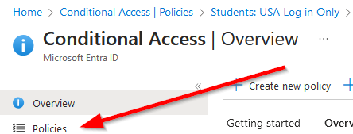
- You should now see the conditional access policies that exist for this client:
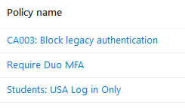
- Click on the policy name you would like to modify
- To add or remove a user or group, click on the ‘Specific users included’ link under Assignments/Users:
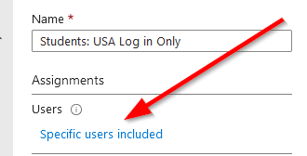
- Select “Include” to add a user to the policy or select “Exclude” to bypass this user account in the policy
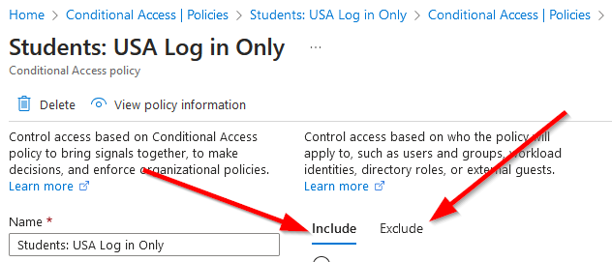
- To add an account or group click on the link under select:
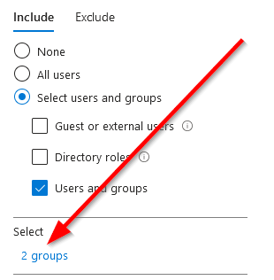
- Locate the account you would like to add and hit the Select button
- You should now see the account or group you are adding in the list below:
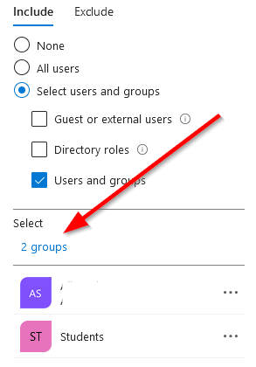
- When finished, click Save at the bottom of the page.
The policy will now update with the new settings you implemented and should be live within about 15 minutes
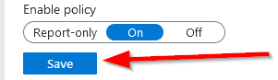

Remove a User or Group from a Policy
- Login to Entra ID via https://entra.microsoft.com
- Click on Protection, then Conditional Access in the left navigation menu
- Select policies:

- You should now see the conditional access policies that exist for this client:

- Click on the policy name you would like to modify
- To remove a user or group, click on the ‘Specific users included’ link under Assignments/Users:


- Pick the Include or Exclude header
- Then click the … next to the name of the object you would like to remove
- Select Remove, and then press Save.
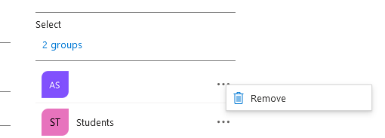
- The policy will be live with the new settings within 15 or so minutes

Add/Remove a Country to the Allowed List
- Login to Entra ID via https://entra.microsoft.com
- Click on Protection, then Conditional Access in the left navigation menu
- Select ‘Named locations’ under the Manage header on the left
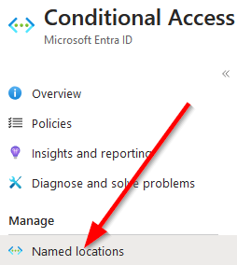
- In the list to the right, select the Allowed Countries list:
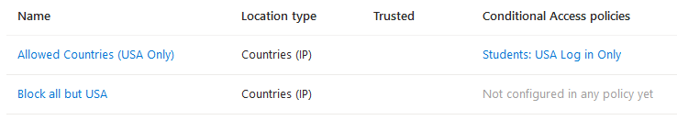
- Scroll through the list to find the country you would like to add to the allowed list and check the box next to its name
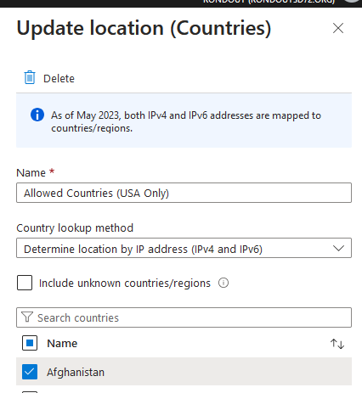
- Press the Save button at the bottom of the page and all policies using the allowed list are now updated with the country you added for this client/tenant
- To remove a country, follow the steps above but instead of adding, uncheck the box next to the country you want to remove from the allowed list and click save to finalize the changes

